Data Structures and Algorithms IT2070
Year two Semester two 2020
Online Examination
Sri Lanka Institute of Information Technology
Time: 30 minutes
________________________________________________________________________

Paper Number 2 (20 marks)

The Fibonacci sequence is the series of numbers:
0, 1, 1, 2, 3, 5, 8, 13, 21, 34,
The next number is found by adding up the two numbers before it as given by the following mathematical function.
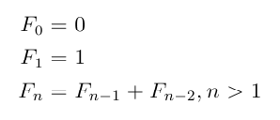
A recursive algorithm for the Fibonacci calculation is given below:
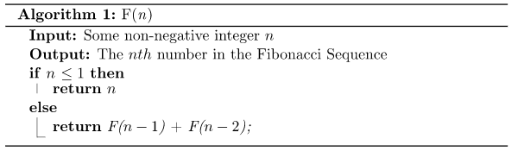
- Write a program in Python to read an integer from the keyboard.
- Develop a function in python named as Fibonacci and implement the above recursive algorithm.
- Pass the input number as parameter to the function developed and get the Fibonacci number as output.
- Use the loop to run the program and display the correct output until user inputs -1.

Upload your answer using given template to the course web link “Paper Number 2”

Grading Sheet:
- Program is compiling. 2 marks
- Program is running successfully. 2 marks
- Program takes the input number as integer. 2 marks
- Correct implementation Fibonacci function. 6 marks
- Correct output 2 marks
- Use of loop correctly 4 marks
- Include comments and properly indented. 2 marks
- Plagiarism testing tool results:…………………………..

